Phase 1 Report: Project Proposal

Ultra Smart Refrigerator

Team #25

A Report

Presented to

The Department of Electrical & Computer Engineering

Concordia University

In Partial Fulfillment

of the Requirements

of ELEC/COEN 490

by

|  |  |
| --- | --- |
| Georgiy Araslanov | ID: 40002321 |
| Gneykou Kengne Yvann Monny | ID: 40015234 |
| Nicholas Pollender | ID: 27398050 |

Project Supervisor

Sébastien Le Beux

Concordia University

October 4, 2019

1. Abstract

Smart refrigerators offer a handful of features to consumers but lack additional features that would make the experience far better. The product envisioned is a smart refrigerator with shelves and drawers partitioned by scales to measure the weight of the food that will be placed in each partition. The partitions can be categorized by the user to help promote a more organized refrigerator. With the data from the scales, the user can view a live value of the weight of the food. If a low amount of a particular food is detected, the refrigerator will suggest a restock. Since the refrigerator will detect the quantity of items that are stored within, some recipes can be offered with said items, listing approximate nutritional values if need be. To add further utility, a small camera(s) can be used to get a quick peek of the inside. All the information listed previously can be accessed via an interface on the refrigerator door or an application on the user’s smartphone.

Table of Contents

1. Abstract1

2. Project Description4

2.1 Objectives4

2.2 Description4

2.3 Requirements6

3. Design Specifications6

4. Measurement of Success & Test Plan7

5. Review of Existing Solutions8

6. Alternatives9

7. Project Planning and Schedule9

8. Team Formation11

9. Task Breakdown12

10. Communication Plan13

11. Contingency Plan14

12. Tools Required15

13. Budget Estimation16

References17

List of Figures

1. Tentative Refrigerator Layout4

2. Tentative Flow Chart of Overall System5

3. Tentative Gantt Chart of Project Progression10

List of Tables

1.1 Functional Requirements4

1.2 Non-Functional Requirements4

2. Numerical Design Specifications4

3. Comparison w/ Existing Solutions8

4. Alternative Methods9

5. Communication Plan13

6. Preliminary Budget Estimation16

2. Project Description

### 2.1 Objectives

The objective of this capstone project is to design and build a prototype of a refrigerator capable of visually informing its users about the current quantities of foods placed inside while promoting organized storage. It would also suggest recipes based on the food quantities through a smartphone application that will wirelessly receive the necessary data from the refrigerator.

2.2 Description

As illustrated below in figure 1, the refrigerator will be partitioned into multiple sections and each section will be clearly delimited with its own glass area with four load cells between the shelf and the glass. With the load cells, the refrigerator will read the change in weight when adding or removing items from the shelf, and ultimately send the data to the user, where the changes will be reflected through the mobile application.

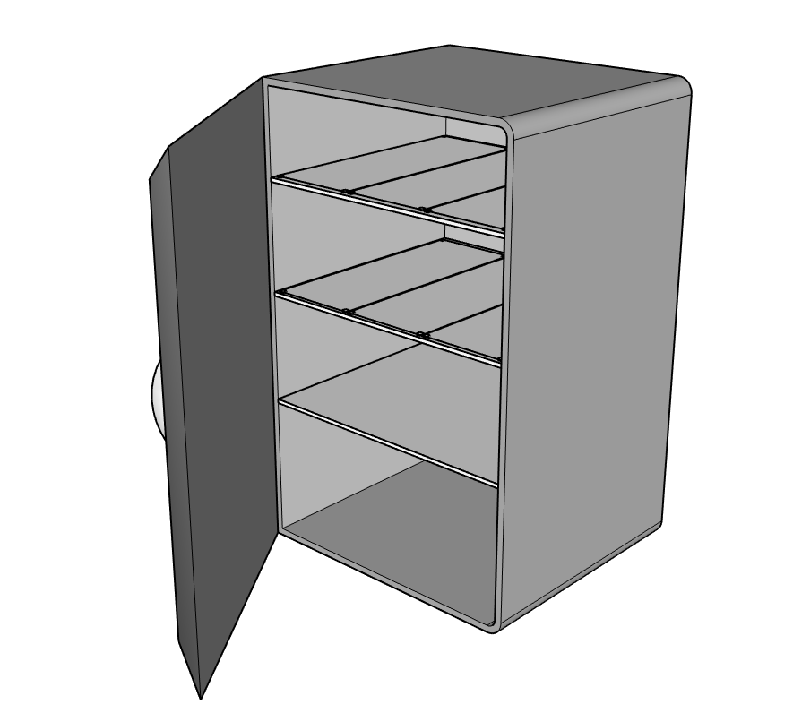

Figure 1: Tentative Refrigerator Layout

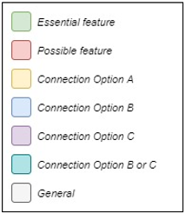 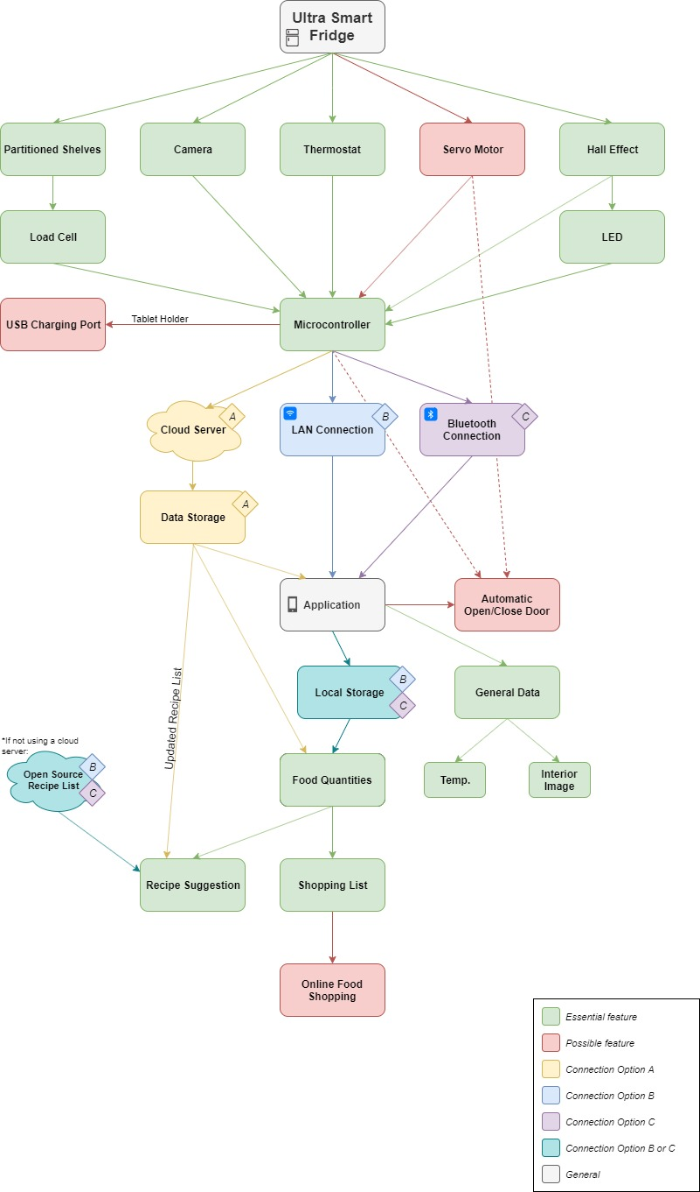

5

Figure 2: Tentative Flow Chart of Overall System

2.3 Requirements

|  |  |
| --- | --- |
| ID | Description of the Functional Requirements (FR) |
| FR - 1 | The refrigerator will be able to measure the quantities of food placed within each partition inside. |
| FR - 2 | A mobile application will be able to connect wirelessly to the refrigerator, will receive and visually display the data collected by the refrigerator. |
| FR - 3 | The refrigerator will have a camera installed within its interior and the user will be able to have a view of the inside of the refrigerator through the mobile application. |
| FR - 4 | The refrigerator’s door will be automatically opened & closed through the app.1 |
| FR - 5 | The user should be alerted in case the refrigerator has been opened for too long.1 |
| FR - 6 | A secured connection/interaction should be established within the system (mobile application, microcontroller, database, user). |
| FR - 7 | The smartphone application will suggest healthy recipes, inform about nutritional values of foods and provide visual data about food usage/habits and potentially expired food. |

Table 1.1: Functional Requirements

|  |  |
| --- | --- |
| ID | Description of the Non-Functional Requirements (NFR) |
| NFR - 1 | The overall physical and visual design of the refrigerator will encourage users to keep everything organized and therefore save some time for the user. |
| NFR - 2 | The refrigerator will accommodate a broad target audience. Its features will be user friendly, it will be adapted for children, elderly and disabled people. |
| NFR - 3 | The features that the product will offer should inspire the users to achieve/keep up healthy habits. |

Table 1.2: Non-Functional Requirements

3. Design Specifications

Normal conditions assume the devices are operating in an environment in which no external source is acting upon it. For example, temperature should not fall below 0⁰C, and the refrigerator should remain dry and undamaged.

|  |  |  |  |  |  |  |
| --- | --- | --- | --- | --- | --- | --- |
| ID | Requirement/Parameter | Test Conditions | Values | | | Units |
| Min | Typ | Max |
| 1 | Maximum Weight on Load Cells | Normal | 0 | 2 | 200 | kg |
| 2 | Operating Temperature | Normal | 2 | 4 | 8 | ⁰C |
| 3 | Wi-Fi Connection Range | Normal | 0 | 5 | 50 | m |
| 4 | Image Quality | Normal | - | 720 | 1080 | px |
| 5 | MCU Processor Frequency | Normal | 16 | 48 | 100 | MHz |

Table 2: Numerical Design Specifications

1Not a guaranteed feature.

4. Measurement of Success & Test Plan

Ideally, this project will be considered if the aforementioned requirements and specifications are met. To ensure a favourable outcome, the implementation will be scrutinized using the following test cases.

4.1 Test Case 1 - Connection Reliability

Description: At room temperature, the strength of the wireless connection signal will be measured using wireless spectrum analyzer software at a distance equivalent to the maximum specified range.

Acceptance Criteria: Strength of the signal should be *greater than* -65 dBm.

4.2.1 Test Case 2 - No Load Weight

Description: With the use of a scale, the true weight of the shelf - in which items will be put on - will be compared against the actual weight of the combination of item and the shelf.

Acceptance Criteria: Pass/Fail, the reading produced by a composition (system) of load cells should have within a 3% tolerance.

4.2.2 Test Case 3 – Load Cell Capacity

Description: The load cells should be able to withstand the weight capacity they are rated for. Weights can be added to the load cell configuration until the maximum weight is reached.

Acceptance Criteria: Pass/Fail, the load cell configuration withstands maximum weight with 5% tolerance.

4.3 Test Case 4 - Hall Effect & Light Source

Description: The intensity of the light produced by the source of light (i.e. LED) should be adequate so that the user can view the inside of the refrigerator with ease, both digitally (through a picture) and physically (when the refrigerator is open). The sensor/mechanism put in place to verify that the door of the refrigerator is closed must be trustworthy.

Acceptance Criteria: Pass/Fail, the Hall Effect sensor should be accurate within 98% and the intensity produced by the source of light should have a 5% tolerance.

4.4 Test Case 5 - Image quality/resolution

Description: The image produced by the camera should be of a good resolution to enable the user to have a general idea of what is inside the refrigerator. Different positions (image) of the camera will be tried out to obtain the best image, depending on a decent amount of congestion (per shelves, for instance).

Acceptance Criteria: Pass/Fail, the accuracy(resolution) of the image should be *greater than* 80%.

4.5 Test Case 6 - (Optional) Automatic Door

Description: Under normal testing conditions, the door will be left open and urged to be closed by pressing a button within the application. Similarly, the door will be left closed and urged to be opened by pressing a button within the application. Moreover, the door will close on its own after being left open for a certain time period (the user will be notified).

Acceptance Criteria: Pass/Fail, the door opens or closes, automatically, or when prompted.

5. Review of Existing Solutions

Existing solutions include the traditional smart refrigerator. These refrigerators often come equipped with ice and water dispensers, large touch screen displays built into the doors, cameras for viewing the interior without opening the door, as well as mobile phone connectivity. While the typical smart refrigerator does come bundled with a plethora of features, they do not include the features envisioned for this project such as the scales for keeping track of food quantities and using said quantities to suggest recipes.

A local Best Buy was visited to ask the employees for more information regarding the smart refrigerators. Although this is but a small sample size, it was discovered that many customers purchase non-smart refrigerator products. Furthermore, customers that did purchase a smart refrigerator would either have a very good review of the product, or a very bad review. An employee explained that the poor reviews usually end in a return or an exchange for a non-smart refrigerator. Several customers that returned/replaced their product said they were not making use of any of the smart-refrigerators features. To expand on this, a customer who had previously owned a smart refrigerator shared her past experiences. In short, she explained that her smartphone and tablet could do everything the smart refrigerator could do (and more).

Further research introduced the General Electric Smart Refrigerators. Their appliances do not use a tablet built into the door, instead they use a smartphone application to manage everything. Through the application, a user can schedule the water dispenser to dispense hot water for a morning coffee, adjust the temperature of the interior, and more. The application also sends alerts to the user if the temperature exceeds a certain value, if the water dispenser filter needs to be replaced, and if the refrigerator door is left open. Although it does not have all the same features as a traditional Samsung or LG smart refrigerator, it accomplishes similar goals, much like the proposed project.

|  |  |  |  |  |  |  |  |
| --- | --- | --- | --- | --- | --- | --- | --- |
| Model | Built-in tablet | Interior cameras | Smartphone pairing | Water/Ice Dispenser | Categorized Food Quantities | Recipe Suggestions | Starting  Cost (CAD) |
| Samsung | ✓ | ✓ | ✓ | ✓ | ✗ | ✗2 | 4102.92 |
| LG | ✗ | ✓ | ✓ | ✓ | ✗ | ✗ | 2599.99 |
| GE | ✗ | ✓ | ✓ | ✓ | ✗ | ✗ | 3399.00 |
| Ultra | ✗ | ✓ | ✓ | ✗ | ✓ | ✓ | <1000.00 |

Table 3: Comparison w/ Existing Solutions

2Can still look up recipes through built-in tablet internet browser.

6. Alternatives

The alternatives include the different ways the project can be implemented, such as alternate sensors or connection types. An item listed with an asterisk (*) indicates the preferred method of operation.

|  |  |  |  |
| --- | --- | --- | --- |
| Item | Option A | Option B | Option C… |
| Microcontroller | Raspberry Pi | Arduino | ATMega |
| Connectivity | Cloud + Wi-Fi* | LAN | Bluetooth |
| Load Cell | 4-Corner Type* | Beam Type | - |
| Camera | Camera Module | Sensor Module | - |

Table 4: Alternative Methods

7. Project Planning and Schedule

The project is split up into four phases over the course of approximately 8 months, each phase having a different purpose.

Phase 1 - September 3, 2019 to October 11, 2019

Project Selection: A couple of weeks are allotted to selecting and receiving approval for a project and finding a project supervisor.

Project Proposal: The remainder of phase 1 is for writing a detailed project proposal report that includes project requirements, design specifications, technical contents, task breakdown, task assignment, project schedule, and budget planning. The proposal is due on October 4, and a presentation of the project is performed on the week of October 7.

Phase 2 - October 12, 2019 to November 29, 2019

Project Design: Implementing the design work outlined in phase 1. A detailed project design report is to be written. The report is due on November 22, and a presentation of project design is performed on the week of November 25.

Phase 3 - November 30, 2019 to February 7, 2020

Prototype Design Implementation: Implementing the prototype design outlined in phase 2. Performing troubleshooting on the prototype, carrying out verification and testing and preparing documents for the final design report. The final design approval date is December 20, and the in-lab pre-demo will be held on the week of February 3.

Phase 4 - February 8, 2020 to April 2020

Final Design Implementation: Fully completing work outlined in phases 1 & 2. Further verification and testing. Preparation of the final design review & final report as well as the technical & user manuals. The in-lab demo will be held on the week of March 23, the final report due on March 31, and the poster presentation in the EV building at the beginning of April.

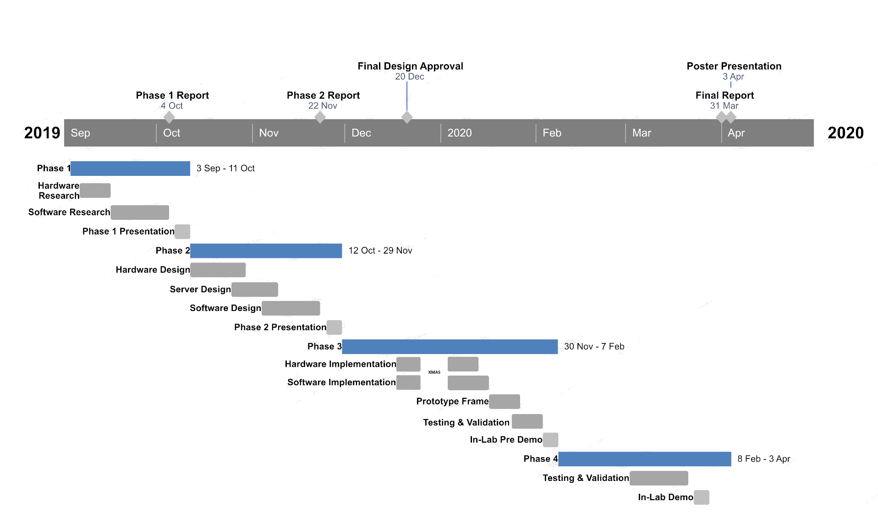

Figure 3: Tentative Gantt Chart of Project Progression

8. Team Formation

Selecting the right team is a vital component of any project. It is important to find quality individuals that have a good reputation, many capabilities, as well as availability for both timing and location. The members chosen for this team are all very familiar with each other as they have worked together previously for the mini-capstone project, being rewarded an honourable mention award.

*Georgiy:*

Final year Electrical engineering student with an interest in hardware and telecommunications. Currently working part-time at Bell Canada as a Technician in Field Operations and at Ciena as an Engineering Intern in Optical Transport Platform in the 5G ENCQOR project, Georgiy is used to handiwork, programming and project management, all important aspects for capstone. With past work and project experiences and the knowledge acquired in classes like ENGR301, ELEC312, ELEC351, ELEC390, COEN352, Georgiy is ready to tackle new challenges and gain new knowledge during this year-long journey.

*Yvann:*

Final year Computer engineering student with a keen interest in software development. Yvann is currently a student employee at the Student Success Center (SSC), at Concordia University where he serves as a Math Assistant. In Summer 2017, He interned at SHADESINTEL, Greenfield Park, QC, Canada as .NET Developer. Following that, He interned at Intelerad Medical Systems, Montreal, QC, Canada as a Software Developer as part of the company’s Cloud Infrastructure Team in Winter 2019. In addition to these experiences, Yvann has also completed academic projects, volunteering experiences and various hackathons which has further developed his skill sets. Relevant courses include COEN316, COEN317, COEN352, COEN390, COEN445, COMP353, ELEC311, ENGR301 and SOEN341.

*Nicholas:*

Final Year Computer engineering student with a natural fascination for anything computer related. Has experience with the Java programming language and Android Studio IDE which will help contribute to the Android application, as well as a knack for aesthetics to improve the appearance of the app and refrigerator. Has a very flexible schedule, available at different times any day of the week when needed, and only a 1-hour commute away from Concordia for days without classes. Notable courses include ELEC311, COEN352, COEN445, COEN390, and currently enrolled in COEN316 and COEN317.

To sustain this project, Dr. Sébastien Le Beux was happy to help the aforementioned students, where He will serve as a supervisor for the entire duration of the project. An expert in emerging technologies and embedded systems, He is more than qualified to review the project, for a system that is to be incorporated into the smart refrigerator.

### 9. Task Breakdown

The project can be separated into 6 major tasks, the tasks marked ‘Optional’ are only to be considered if time permits.

1. Research

1.1 Research on microcontroller: Yvann

1.2 Research on wireless connectivity (Bluetooth, Wi-Fi): Yvann

1.3 Research on cloud server: Yvann

1.4 Research on load cell: Georgiy

1.5 (Optional) Research on camera module & image processing: Nicholas

1.6 Research on amplifier & converter: Georgiy

1.7 Research on mobile application requirements: Nicholas

1.8 (Optional) Research on servo motors: TBA

* 1. (Optional) Research on USB charging: TBA

2. Prototype Design

2.1 Design of load cell configuration: Georgiy

2.2 Design of amplifier & converter configuration: Georgiy

2.3 Design of camera configuration: Nicholas

2.4 (Optional) Design of mechanical door: TBA

* 1. Implementation of preliminary MCU setup: Georgiy, Nicholas

3. Cloud Server

3.1 Design of database: Yvann

* 1. Design of data processing: Yvann, Nicholas

4. Software

4.1 Microcontroller data processing: Georgiy, Yvann

4.2 Application development:

4.2.1 User interface design: Nicholas

4.2.2 General application features (i.e. User information): Yvann

4.2.3 Recipe suggestion algorithm: Yvann, Nicholas

* 1. Application data receival: Nicholas

5. Implementation of Final Design

* 1. Implementation of all sub-systems: Georgiy, Yvann, Nicholas

6. Testing & Validation

6.1 Testing overall system: Georgiy, Yvann, Nicholas

6.2 Validating overall system: Georgiy, Yvann, Nicholas

### 10. Communication Plan

A communication plan is an important factor for a successful project. As such, the methods of communication used are equally as important.

|  |  |  |  |
| --- | --- | --- | --- |
| Communication | Frequency | Goal | Audience |
| Facebook Messenger | | | |
| General discussion | Daily | Discuss any progress, brainstorm ideas, setup future meetings. | Project team |
| Team call | Weekly | Voice call while working collaboratively on project. | Project team |
| Email | | | |
| Meeting scheduling | As needed | Discuss meeting time and location of weekly meeting, discuss important dates such as end of phase presentation. | Project team and project supervisor |
| Meetings | | | |
| Team stand-up | 2-3 per week | Discuss each team member’s contribution since previous stand-up, discuss any roadblocks, discuss goals for next stand-up. | Project team |
| Supervisor meeting | Weekly | Discuss progress on the project, exchange criticism, gather feedback and discuss deliverables for next meeting. | Project team and project supervisor |
| Post-phase meeting | End of each phase | Review of project deliverables, gather feedback, discuss tasks for next phase. | Project team, project supervisor, capstone coordinator(s) |
| GitHub | | | |
| Review of code | Per pull request | Starting phase 3: discuss current progress in code, debug and improve code. | Project team |
| Google Drive & Slack | | | |
| Exchange of documents and reports | Daily | Update reports, tables, charts with the latest developments of the project.  Slack setup with webhooks to notify team members of updated files/code. | Project team |

Table 5: Communication Plan

### 11. Contingency Plan

A plan B is always essential for a project, in case the original does not provide the desired result. Therefore, it is required to outline any risks that may be encountered in the future development of the project. Among all the possible risks, outlined below are the risks would have the largest impact on the development of the project as well as ways to deal with said risks.

Risk assessment:

i) Cannot use all the sensors on the same MC

ii) Incapable of exchanging information via the Cloud/Wi-Fi

iii) Incapable of transmitting images from MC to application

Proposed Solution:

i) In the case that the microcontroller cannot handle all the sensors to be connected to it at the same time (i.e. not enough connections, or incapability of having large arrays of sensors), components that are not essential to the operation must be identified. Firstly, the cameras, while useful, are not the key focus of the project and would not be a huge loss. Secondly, the thermostat again while useful is not essential and can easily be replaced by a traditional thermostat. Thirdly, the logic involving the servo motor to automatically open and close the refrigerator can be replaced by a notification within the application.

ii) In the case that the cloud server or Wi-Fi connectivity do not work as intended, a different module such as Bluetooth will be used to send the data to the application. This can be a temporary solution and easily implemented as experience with sending/receiving data via Bluetooth on mobile applications was previously obtained from the mini-capstone. The Bluetooth module can be implemented in the prototype, and preferably the originally planned cloud server or Wi-Fi connectivity for the final product.

iii) In the case that images cannot be sent from the microcontroller to the application, the simplest solution would be to remove the camera functionality entirely although not ideal. The second solution could be a separate unit to deal with image transmission.

Planning is key. To avoid any problems regarding the sensors, notes of the details regarding them will be taken, what kind of data they can transmit, the type of signal, power consumption, etc. Furthermore, the limits of any microcontroller considered should be known, if it can handle multiple signals at once, or if can process images, and if it has Bluetooth or Wi-Fi connectivity in case a purchase of an external module is required.

It should also be noted that Georgiy is the only Electrical engineering student on the team, as such, he has the most experience with circuitry. If he is unavailable, progress on the project will be very slow.

12. Tools Required

The following are examples of tools that will be useful throughout the design & implementation of the project.

Android Studio IDE:

An integrated development environment is required to develop the application to run on an Android device. We can design the application functionality and interface appearance.

Android Device:

For testing the application functionality. Concordia offers Google Pixel rentals (for Mini-Capstone), otherwise team members do have access to older Android devices, although device performance is poor.

CAD Software:

For creating a technical drawing of the refrigerator, get an idea of where devices & sensors will be placed.

Cloud Server:

Required for storing data obtained from the microcontroller, and also fetched by the application.

Soldering Iron:

For forming permanent circuit board connections, suitable for the final product with for a more professional feel and reduce the number of temporary connections.

Woodworking:

These tools will be useful to build the replica frame of the refrigerator.

* Table Saw: The essential tool for woodworking, versatile and productive. This tool can apply a large variety of cuts to the edges of wood stock.
* Miter Saw: Useful for quick and accurate crosscuts on wood stock at precise angles.
* Drill Press: Great for pre-drilling holes into wood stock. Pre-drilling holes allows for easy insertion of screws, reducing the chance of splitting, and therefore increasing the structural integrity of the craft.
* Sander: For smoothing out the edges and surfaces of wood stock. Rough edges/surfaces can cause splinters and are uncomfortable to handle.

Storage:

Will require adequate storage area to keep the refrigerator throughout the duration of the project.

### 13. Budget Estimation

Budget estimation is an important part of any project planning; it gives a sense of cost control. It can be known if the project is progressing according to plan and if any corrective actions need to be made by comparing the estimated budget to the projects actual cost. The following budget approximates the cost of major components, as well as possible inclusions, based on research.

|  |  |  |  |
| --- | --- | --- | --- |
| Item | Quantity | Cost per unit (CAD) | Total cost (CAD) |
| Refrigerator | 1 | 120 | 120 |
| Microcontroller | 1 | 100 | 100 |
| Load Cell Kit | 8 | 5 | 40 |
| Camera | 1 | 80 | 80 |
| Hall-Effect Sensor | 4 | 0.50 | 2 |
| LED Strip | 1 | 15 | 15 |
| Servo Motor | 1 | 20 | 20 |
| Wood | 2 | 20 | 40 |
| Drawer Kit | 2 | 7 | 14 |
| Paint | 2 | 10 | 20 |
| Misc. Electricals | 20 | 0.50 | 10 |
| Total |  | | 461.00 |

Table 6: Preliminary Budget Estimation

### References

i) Samsung Smart Fridge information:

<https://www.samsung.com/us/explore/family-hub-refrigerator/overview/>

ii) LG Smart Fridge information: <https://www.lg.com/ca_en/refrigerators>

iii) GE Smart Fridge information: <https://www.geappliances.com/ge/connected-appliances/>

iv) Basic research on devices & sensors: <https://www.digikey.ca>

v) Proposal assistance: <http://numerique.banq.qc.ca/patrimoine/details/52327/2217316>

vi) Load cell functionality:

<https://www.hbm.com/en/7325/the-working-principle-of-a-compression-load-cell/>

vii) Camera module vs Sensor module: <https://www.youtube.com/watch?v=Oi4S7SwumGs>

viii) Connection Reliability:

<https://www.metageek.com/training/resources/wifi-signal-strength-basics.html>

ix) Smart Fridge Research: Interview w/ anonymous Best Buy employee conducted on September 16th, 2019